Dunwandig R1/2 dak geel
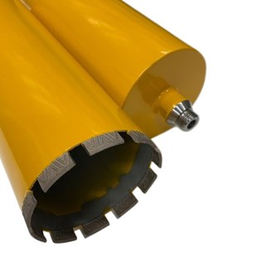
Type beton dak geel
Voor het boren in diverse bouwmaterialen, zoals: beton en baksteen.
Uitsluitend nat te gebruiken.
Gepositioneerde diamant in segmenten.
Aansluiting | R1/2
Diameters | 51 t/m 200
Lengte | 300 mm
Segmenthoogte | 12 mm

Artikelcode | Omschrijving
B05005103005 | 051/300 R1/2 Laser gel. diamantb. dunw. beton dak geel
B05005603005 | 056/300 R1/2 Laser gel. diamantb. dunw. beton dak geel
B05006103006 | 061/300 R1/2 Laser gel. diamantb. dunw. beton dak geel
B05006603006 | 066/300 R1/2 Laser gel. diamantb. dunw. beton dak geel
B05007103007 | 071/300 R1/2 Laser gel. diamantb. dunw. beton dak geel
B05007603007 | 076/300 R1/2 Laser gel. diamantb. dunw. beton dak geel
B05008103008 | 081/300 R1/2 Laser gel. diamantb. dunw. beton dak geel
B05008603008 | 086/300 R1/2 Laser gel. diamantb. dunw. beton dak geel
B05009103008 | 091/300 R1/2 Laser gel. diamantb. dunw. beton dak geel
B05010103009 | 101/300 R1/2 Laser gel. diamantb. dunw. beton dak geel
B05011103010 | 111/300 R1/2 Laser gel. diamantb. dunw. beton dak geel
B05012103010 | 121/300 R1/2 Laser gel. diamantb. dunw. beton dak geel
B05012503011 | 125/300 R1/2 Laser gel. diamantb. dunw. beton dak geel
B05013003011 | 130/300 R1/2 Laser gel. diamantb. dunw. beton dak geel
B05014003011 | 140/300 R1/2 Laser gel. diamantb. dunw. beton dak geel
B05015003012 | 150/300 R1/2 Laser gel. diamantb. dunw. beton dak geel
B05016003012 | 160/300 R1/2 Laser gel. diamantb. dunw. beton dak geel
B05017003013 | 170/300 R1/2 Laser gel. diamantb. dunw. beton dak geel
B05018003014 | 180/300 R1/2 Laser gel. diamantb. dunw. beton dak geel
B05020003017 | 200/300 R1/2 Laser gel. diamantb. dunw. beton dak geel

