Laser Turbo Titan
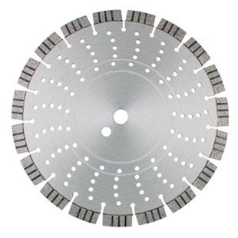
Toepassing | Beton, baksteen, dakpannen
Diameters Ø | 300-350-400
Asgat | 20-22,23-25,4-30
Segmenthoogte | 15 mm
Gebruik | Droog en nat

N2710073 | Dia-TS Ø 300mm/20 Laser Turbo Titan 40 x 2,8 x 15mm
N2710075 | Dia-TS Ø 300mm/25,4 Laser Turbo Titan 40 x 2,8 x 15mm
N2710080 | Dia-TS Ø 350mm/20 Laser Turbo Titan 40 x 3,2 x 15mm
N2710083 | Dia-TS Ø 350mm/25,4 Laser Turbo Titan 40 x 3,2 x 15mm
N2710087 | Dia-TS Ø 400mm/20 Laser Turbo Titan 40 x 3,2 x 15mm
N2710090 | Dia-TS Ø 400mm/25,4 Laser Turbo Titan 40 x 3,2 x 15mm
N2710160 | Dia-TS Ø 300mm/20 Laser Turbo Titan Premium 40 x 2,8 x 12mm
N2710162 | Dia-TS Ø 300mm/25,4 Laser Turbo Titan Premium 40 x 2,8 x 12mm
N2710170 | Dia-TS Ø 350mm/20 Laser Turbo Titan Premium 40 x 3,2 x 12mm
N2710173 | Dia-TS Ø 350mm/25,4 Laser Turbo Titan Premium 40 x 3,2 x 12mm
N2710180 | Dia-TS Ø 400mm/20 Laser Turbo Titan Premium 40 x 3,2 x 12mm
N2710182 | Dia-TS Ø 400mm/25,4 Laser Turbo Titan Premium 40 x 3,2 x 12mm

