Laser Turbo Uni
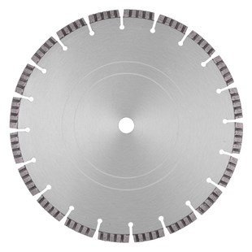
Toepassing | Beton, baksteen, dakpannen
Diameters Ø | 300-350-400
Asgat | 20-22,23-25,4-30
Segmenthoogte | 10 mm
Gebruik | Droog en nat

N2710035 | 2710035 - Dia-TS Ø 300mm/20 Laser Turbo Uni 40 x 2,8 x 10mm
N2710036 | 2710036 - Dia-TS Ø 300mm/22,23 Laser Turbo Uni 40 x 2,8 x 10mm
N2710037 | 2710037 - Dia-TS Ø 300mm/25,4 Laser Turbo Uni 40 x 2,8 x 10mm
N2710038 | 2710038 - Dia-TS Ø 300mm/30 Laser Turbo Uni 40 x 2,8 x 10mm
N2710040 | 2710040 - Dia-TS Ø 350mm/20 Laser Turbo Uni 40 x 3,2 x 10mm
N2710042 | 2710042 - Dia-TS Ø 350mm/25,4 Laser Turbo Uni 40 x 3,2 x 10mm
N2710045 | 2710045 - Dia-TS Ø 400mm/20 Laser Turbo Uni 40 x 3,2 x 10mm
N2710047 | 2710047 - Dia-TS Ø 400mm/25,4 Laser Turbo Uni 40 x 3,2 x 10mm

