

**Jolly Cut**

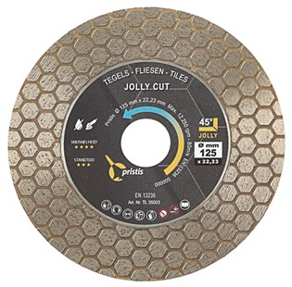

|  |  |
| --- | --- |
| **Artikelcode** | **Omschrijving** |
| TL35003 | 125/22,23 Pristis Tegels Jolly Cut 1,6x25 mm Blank |