

**Aardelectrodebeitel 16,5mm**

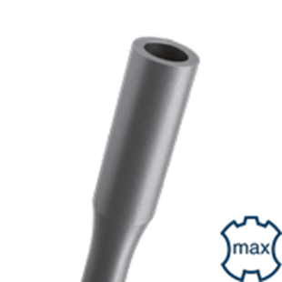

**Aardelectrodebeitel 16,5mm**

|  |  |  |  |  |
| --- | --- | --- | --- | --- |
| Art.nr. |  | Omschrijving | Breedte | Lengte |
| 215.1087 |  | Aardelectrode houder | ø16,5x26 | 260 |