

**Gatzagensets (4/6) met Quick-change**

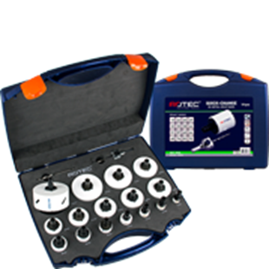

**BiM Gatzagensets (4/6) met Quick-Change**

|  |  |  |  |  |
| --- | --- | --- | --- | --- |
| Art.nr. |  | Omschrijving | Type | Inhoud |
| 527.5105 |  | 13-dlg. Set HSS-BiMCo8 Gatzagenset "Elektricien" 6-knt | "527" | 1x ø22, 27, 32, 35, 38, 44, 51, 60, 68 en 76mm 1x Quick-Change houder (6-knt. 11) 2x HSS Centreerboor |
| 527.6105 |  | 13-dlg. Set HSS-BiMCo8 Gatzagenset "Elektricien" SDS+ | "527" | 1x ø22, 27, 32, 35, 38, 44, 51, 60, 68 en 76mm 1x Quick-Change houder (SDS+) 2x HSS Centreerboor |
| 527.5110 |  | 16-dlg. Set HSS-BiMCo Gatzagenset "Allround" 6-knt | "527" | 1x ø19, 22, 25, 32, 35, 38, 44, 51, 57, 60, 64, 68 en 76mm 1x Quick-Change houder (6-knt. 11) 2x HSS Centreerboor |
| 527.6110 |  | 16-dlg. Set HSS-BiMCo8 Gatzagenset "Allround" SDS+ | "527" | 1x ø19, 22, 25, 32, 35, 38, 44, 51, 57, 60, 64, 68 en 76mm 1x Quick-Change houder (SDS+) 2x HSS Centreerboor |
| 527.5115 |  | 19-dlg. Set HSS BiMCo8 Gatzagenset "MAX" 6-knt | "527" | 1x ø19, 22, 25, 29, 32, 35, 38, 44, 51, 57, 60, 64, 68, 76, 83 en 92mm 1x Quick-Change houder (6-knt. 11) 2x HSS Centreerboor |
| 527.6115 |  | 19-dlg. HSS BiMCo8 Gatzagenset "MAX" SDS+ | "527" | 1x ø19, 22, 25, 29, 32, 35, 38, 44, 51, 57, 60, 64, 68, 76, 83 en 92mm 1x Quick-Change houder (SDS+) 2x HSS Centreerboor |