

**Quick-change centreerboren**

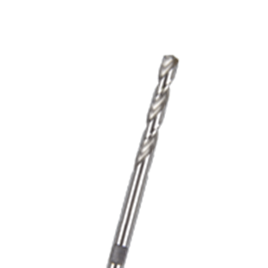

**Quick-Change Centreerboren**

|  |  |  |
| --- | --- | --- |
| Art.nr. |  | Omschrijving |
| 527.3150 |  | HSS Centreerboor |