

**Quick-change houders**

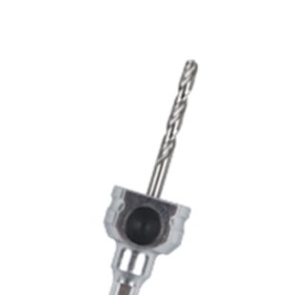

**Quick-Change Houders**

Uitvoering

Quick Change houder t.b.v. HSS-Bi gatzagen.

|  |  |  |  |  |
| --- | --- | --- | --- | --- |
| Art.nr. |  | Omschrijving | Schacht | Centreerb. |
| 527.3105 |  | Quick change | 6-knt. 8,5 | HSS |
| 527.3110 |  | Quick change | 6-knt. 11 | HSS |