

**Adapters**

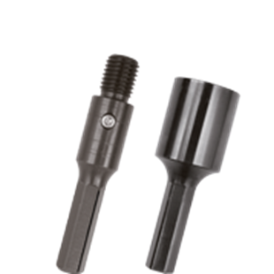

**Adapters**

|  |  |  |  |
| --- | --- | --- | --- |
| Art.nr. |  | Schacht | Opname |
| 769.0002 |  | 6-knt. 12,7 | M16 (M) |
| 779.0050 |  | 6-knt. 12,7 | 1/2" (F) |