

**Gatzagensets met Quick-change**

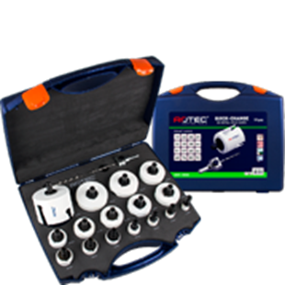

**MP-Gatzagensets met Quick-Change**

|  |  |  |  |  |
| --- | --- | --- | --- | --- |
| Art.nr. |  | Omschrijving | Type | Inhoud |
| 528.4105 |  | 13-dlg. Set MP-Gatzagen "Loodgieter" 6-knt. 11 | "528" | 1x ø22, 27, 32, 35, 38, 44, 51, 60, 68 en 76mm 1x Quick-Change houder (6-knt. 11) 2x Centreerboor (1x HSS / 1x HM) |
| 528.6105 |  | 13-dlg. Set MP-Gatzagen "Loodgieter" SDS+ | "528" | 1x ø22, 27, 32, 35, 38, 44, 51, 60, 68 en 76mm 1x Quick-Change houder (SDS+) 2x Centreerboor (1x HSS / 1x HM) |
| 528.4110 |  | 16-dlg. Set MP-Gatzagen "Elektricien" 6-knt. 11 | "528" | 1x ø19, 22, 25, 32, 35, 38, 44, 51, 57, 60, 64, 68 en 76mm 1x Quick-Change houder (6-knt. 11) 2x Centreerboor (1x HSS / 1x HM) |
| 528.6110 |  | 16-dlg. Set MP-Gatzagen "Elektricien" SDS+ | "528" | 1x ø19, 22, 25, 32, 35, 38, 44, 51, 57, 60, 64, 68 en 76mm 1x Quick-Change houder (SDS+) 2x Centreerboor (1x HSS / 1x HM) |
| 528.4115 |  | 19-dlg. Set MP-Gatzagen "Allround" 6-knt. 11 | "528" | 1x ø19, 22, 25, 29, 32, 35, 38, 44, 51, 57, 60, 64, 68, 76, 83 en 92mm 1x Quick-Change houder (6-knt. 11) 2x Centreerboor (1x HSS / 1x HM) |
| 528.6115 |  | 19-dlg. Set MP-Gatzagen "Allround" SDS+ | "528" | 1x ø19, 22, 25, 29, 32, 35, 38, 44, 51, 57, 60, 64, 68, 76, 83 en 92mm 1x Quick-Change houder (SDS+) 2x Centreerboor (1x HSS / 1x HM) |