

**MP Gatzagen 165 mm**

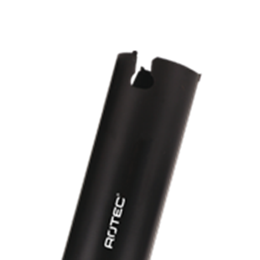

**MP Gatzagen, 165mm**

Uitvoering

Stabiele gatzaag voorzien van hardmetalen tanden. Snijdiepte tot 165 mm. Zaagt tot wel 5x sneller dan traditionele gatzaag.

Toepassing

Probleemloos zagen in alle zacht- en hardhoutsoorten, spaanplaat, MDF, kunststoffen zoals PVC en nylon, gips, gasbeton, zachte steensoorten en wandtegels tot kernhardheid 6.

|  |  |  |  |  |
| --- | --- | --- | --- | --- |
| Art.nr. |  | Diam. (mm) | Diam. (inch) | Snijdiepte |
| 528.7045 |  | 45,0 | - | 165 |
| 528.7051 |  | 51,0 | 2" | 165 |
| 528.7060 |  | 60,0 | 2-3/8" | 165 |
| 528.7065 |  | 65,0 | 2-9/16" | 165 |
| 528.7068 |  | 68,0 | 2-11/16" | 165 |
| 528.7070 |  | 70,0 | 2-3/4" | 165 |
| 528.7075 |  | 75,0 | - | 165 |
| 528.7080 |  | 80,0 | 3-5/32" | 165 |
| 528.7086 |  | 86,0 | 3-3/8" | 165 |
| 528.7092 |  | 92,0 | 3-5/8" | 165 |
| 528.7102 |  | 102,0 | 4" | 165 |
| 528.7111 |  | 111,0 | 4-3/8" | 165 |
| 528.7121 |  | 121,0 | 4-3/4" | 165 |
| 528.7130 |  | 130,0 | 5-1/8" | 165 |
| 528.7140 |  | 140,0 | 5-1/2" | 165 |
| 528.7152 |  | 152,0 | 6" | 165 |
| 528.7160 |  | 160,0 | 6-19/64" | 165 |
| 528.7210 |  | 210,0 | 7-7/8" | 165 |