

**Quick-change centreerboren (HSS)**

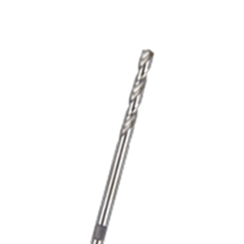

**Quick-Change Centreerboor (HSS)**

|  |  |  |
| --- | --- | --- |
| Art.nr. |  | Omschrijving |
| 528.3145 |  | HSS Centreerboor |