109
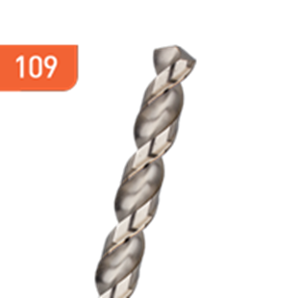
HSS-G Spiraalboren, type W | Aluminium

Uitvoering
HSS-G spiraalboren DIN 338, type W, geslepen uitvoering, tophoek 130°.

Toepassing
Voor het bewerken van langspanig materiaal, zoals aluminiumlegeringen, koper, zink en zachte kunststoffen.

Art.nr. |  | Diameter | Totaal | Spiraal
109.0100 |  | 1,0 | 34 | 12
109.0150 |  | 1,5 | 40 | 18
109.0200 |  | 2,0 | 49 | 24
109.0250 |  | 2,5 | 57 | 30
109.0280 |  | 2,8 | 61 | 33
109.0300 |  | 3,0 | 61 | 33
109.0310 |  | 3,1 | 65 | 36
109.0320 |  | 3,2 | 65 | 36
109.0330 |  | 3,3 | 65 | 36
109.0350 |  | 3,5 | 70 | 39
109.0400 |  | 4,0 | 75 | 43
109.0410 |  | 4,1 | 75 | 43
109.0420 |  | 4,2 | 75 | 43
109.0430 |  | 4,3 | 80 | 47
109.0450 |  | 4,5 | 80 | 47
109.0500 |  | 5,0 | 86 | 52
109.0510 |  | 5,1 | 86 | 52
109.0520 |  | 5,2 | 86 | 52
109.0530 |  | 5,3 | 86 | 52
109.0550 |  | 5,5 | 93 | 57
109.0600 |  | 6,0 | 93 | 57
109.0650 |  | 6,5 | 101 | 63
109.0700 |  | 7,0 | 109 | 69
109.0750 |  | 7,5 | 109 | 69
109.0800 |  | 8,0 | 117 | 75
109.0850 |  | 8,5 | 117 | 75
109.0900 |  | 9,0 | 125 | 81
109.0950 |  | 9,5 | 125 | 81
109.1000 |  | 10,0 | 133 | 87
109.1050 |  | 10,5 | 133 | 87
109.1200 |  | 12,0 | 133 | 87
109.1300 |  | 13,0 | 151 | 101

