427ADV
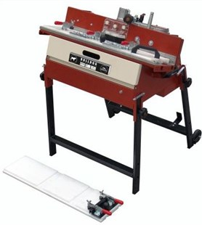
Plintenfreesmachine BULL DOG ADV
Voor afronden en frezen.
Maakt ½ rondingen, 45 graden (verstek) aan marmer, graniet, porselein, enkel en dubbel gebakken.
Maximum lengte voor afronden | 80 cm (24")
Maximum te frezen dikte | 30 mm (5/8")
Maximum frees radius | 15 mm (5/8")
Overbrenging van motor naar wiel | 1÷1.6 poly V aandrijfriem
3 gradaties van afwerken | ruw, glad gepolijst
Gewicht | 75 kg
Waterpomp gekoeld.
Inklapbaar onderstel.
Geleverd met: frees shaping 10 mm, 2 teflon planken, sleutelset, opscherpsteen.
Verschillende toebehoren leverbaar:
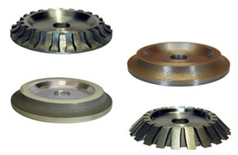
179BU008FC-AR | BULL DOG Frees milling 8 mm
179BU010FC-AR | BULL DOG Frees milling 10 mm
179BU015FC125 | BULL DOG Frees shaping 15 mm
179BU10LA | BULL DOG Frees polishing 10 mm K400
179BU10LB | BULL DOG Frees polishing 10 mm K800
179BU10LC | BULL DOG Frees polishing 10 mm K1500
179BU10LD | BULL DOG Frees polishing 10 mm K1800
179BU10RF | BULL DOG Frees finishing 10 mm
179BU15LA | BULL DOG Frees polishing 15 mm K400
179BU15LB | BULL DOG Frees polishing 15 mm K800
179BU15LC | BULL DOG Frees polishing 15 mm K1500
179BU15LD | BULL DOG Frees polishing 15 mm K1800
179BU15LE | BULL DOG Frees polishing 15 mm K3500
179BU15RF125 | BULL DOG Frees finishing 15 mm
179BU16SC | BULL DOG Frees 90 graden - h16 mm
179BU20LA | BULL DOG Frees polishing 20 mm K400
179BU20LB | BULL DOG Frees polishing 20 mm K800
179BU20LC | BULL DOG Frees polishing 20 mm K1500
179BU20LD | BULL DOG Frees polishing 20 mm K1800
179BU20LE | BULL DOG Frees polishing 20 mm K3500
179BU20RF | BULL DOG Frees finishing 20 mm
179BU30LA | BULL DOG Frees polishing 30 mm K400
179BU30LB | BULL DOG Frees polishing 30 mm K800
179BU30LC | BULL DOG Frees polishing 30 mm K1500
179BU30LD | BULL DOG Frees polishing 30 mm K1800
179BU30LE | BULL DOG Frees polishing 30 mm K3500
179BU30RF | BULL DOG Frees finishing 30 mm
179BU30SC | BULL DOG Frees 90 graden - h30 mm
179BU8LA | BULL DOG Frees polishing 8 mm K400
179BU8LB | BULL DOG Frees polishing 8 mm K800
179BU8RF | BULL DOG Frees finishing 8 mm
179BULL10 | BULL DOG Frees shaping 10 mm
179BULL15-125 | BULL DOG Frees shaping 15 mm
179BULL20 | BULL DOG Frees shaping 20 mm
179BULL30 | BULL DOG Frees shaping 30 mm
179BULL45 | BULL DOG Frees voor 45 graden
179BUN100 | BULL DOG Diamant band K100
179BUN400 | BULL DOG Diamant band K400
179BUN800 | BULL DOG Diamant band K800
179BUPNA | BULL DOG Diamant band houder

