Frees 90 graden
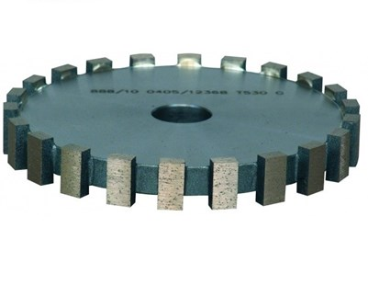
Vlakke 90 graden frees.
179BU30SC | H=32 mm
179BU16SC | H=16 mm

