Frees finishing
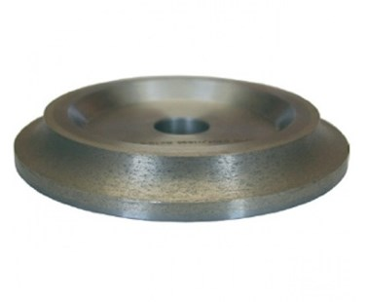
Frees finishing. Verkrijgbaar in:
179BU8RF | 8 mm
179BU10RF | 10 mm
179BU15RF125 | 15 mm
179BU20RF | 20 mm
179BU30RF | 30 mm

