Frees polishing K400
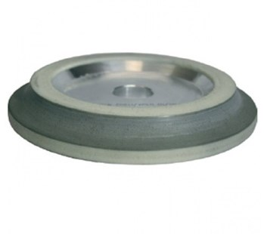
Frees polishing K400. Verkrijgbaar in:
179BU8LA | 8 mm
179BU10LA | 10 mm
179BU15LA | 15 mm
179BU20LA | 20 mm
179BU30LA | 30 mm

