Frees polishing K800
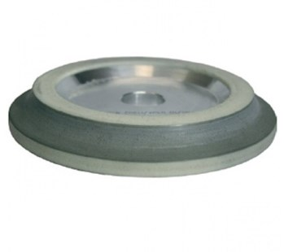
Frees polishing K800. Verkrijgbaar in:
179BU8LB | 8 mm
179BU10LB | 10 mm
179BU15LB | 15 mm
179BU20LB | 20 mm
179BU30LB | 30 mm

