Frees radius
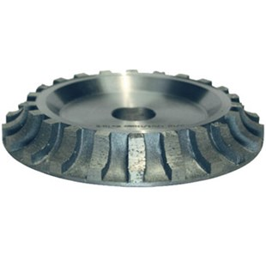
Frees radius. Verkrijgbaar in:
179BULL10 | 10 mm
179BULL15-125 | 15 mm
179BULL20 | 20 mm
179BULL30 | 30 mm

