3970080
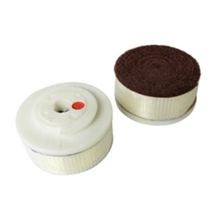
De matte-afwerking borstel D 100 mm SF wordt gebruikt voor optische verfraaiing van de oppervlakten in marmer en graniet.
3970080 | Mattschliffbürste / D 100 mm / K 60 | SF / Marmor & Granit
3970090 | Mattschliffbürste / D 100 mm / K 120 | SF / Marmor & Granit
3970095 | Mattschliffbürste / D 100 mm / K 180 | SF / Marmor & Granit
3970105 | Mattschliffbürste / D 100 mm / K 320 | SF / Marmor & Granit
3970107 | Mattschliffbürste / D 100 mm / K 500 | SF / Marmor & Granit
3970110 | Mattschliffbürste / D 100 mm / K 600 | SF / Marmor & Granit
3970115 | Mattschliffbürste / D 100 mm / K 800 | SF / Marmor & Granit
3970120 | Mattschliffbürste / D 100 mm / K 1000 | SF / Marmor & Granit
3970125 | Mattschliffbürste / D 100 mm / K 1200 | SF / Marmor & Granit

