1110710
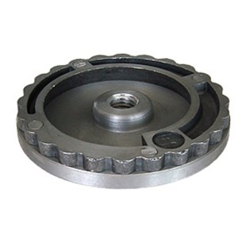
1110710 | SF-ALU-Teller / D 100 mm / M 14
1110720 | SF-ALU-Teller / D 130 mm / M 14

