7560464
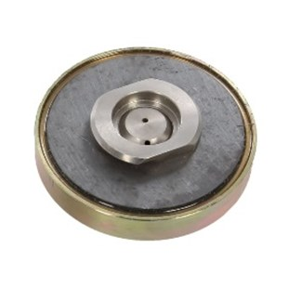
7560464 | Magnet-Kupplung / D 80 mm / M 14 IG

