

**Cermet V155**

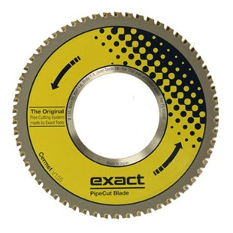

|  |  |
| --- | --- |
| Type | Cermet V155 |
| Afmetingen | 155 x 65 x 1.6 x 1.4 x 58 |
| Materiaal | dunwandige ventilatiepijp |
| Zaagmachine | V1000 |