

**Diamond 140**

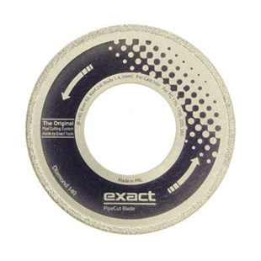

|  |  |
| --- | --- |
| Type | Diamond 140 |
| Afmetingen | 140 x 62 x 2.0 x 1.8 |
| Materiaal | Gietijzer |
| Zaagmachine | 170, 170E, 200, 360 |