

**Diamond X165**

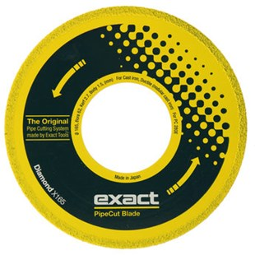

|  |  |
| --- | --- |
| Type | Diamond X165 |
| Afmetingen | 165 x 62 x 2.0 x 1.8 |
| Materiaal | Gietijzer, ductile |
| Zaagmachine | 280E |