

**TCT P150**

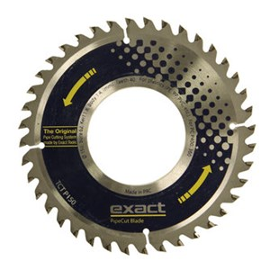

|  |  |
| --- | --- |
| Type | TCT P150 |
| Afmetingen | 150 x 62 x 1.8 x 1.4 x 40 |
| Materiaal | Kunststof (PE, PP, PVC, etc.) |
| Zaagmachine | 360, P400 |