

**BL18018**

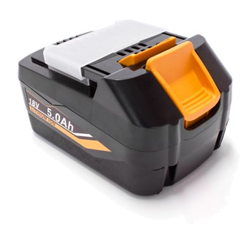

**Kenmerken BL18018 - Accu 18V 5.0Ah**

- Voltage - 18V  
- Amperage - 5.0Ah  
- Type - Li-Ion.