

**C10836**

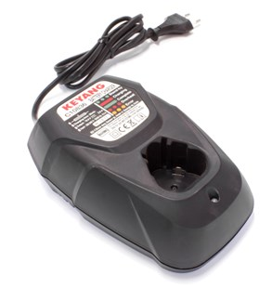

**Kenmerken C10836 - Lader 10.8V**

- Voltage - 10.8V  
- Type - Li-Ion.