

**C36038**

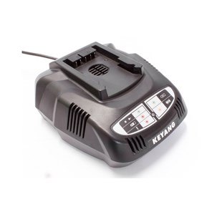

**Kenmerken C36038 - Lader 36V**

- Voltage - 36V  
- Type - Li-Ion.