

**DK09**

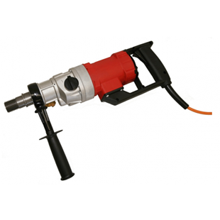

|  |  |
| --- | --- |
| Spanning (V) | 230 |
| Gewicht (Kg) | 4.9 |
| Toerental | 540/1700 |
| Max. boordiameter (mm) | 80 - 150 |
| Vermogen (W) | 1800 |
| Opname | 1.25 |
| Lengte (mm) | 485 |
| Toepassing | Steen, Beton |