

**DK116**

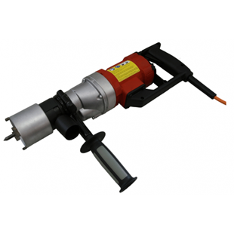

|  |  |
| --- | --- |
| Spanning (V) | 220 |
| Gewicht (Kg) | 5 |
| Toerental | 1500 |
| Max. boordiameter (mm) | 82 |
| Vermogen (W) | 1600 |
| Opname | M16 |
| Lengte (mm) | 420 |