

**DK119**

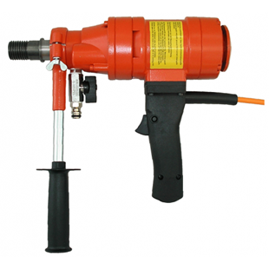

|  |  |
| --- | --- |
| Spanning (V) | 230 |
| Gewicht (Kg) | 5.4 |
| Toerental | 430 |
| Max. boordiameter (mm) | 100 - 250 |
| Vermogen (W) | 1600 |
| Opname | 1.25 |
| Lengte (mm) | 360 |
| Toepassing | Beton |