

**DK26**

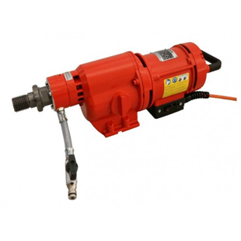

|  |  |
| --- | --- |
| Spanning (V) | 230 |
| Gewicht (Kg) | 11.6 |
| Toerental | 245/480/760 |
| Max. boordiameter (mm) | 250 |
| Vermogen (W) | 2600 |
| Opname | 1.25 |
| Lengte (mm) | 490 |
| Toepassing | Steen, Beton |