

**DK52E**

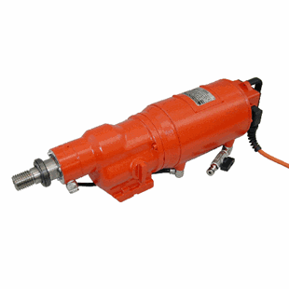

|  |  |
| --- | --- |
| Spanning (V) | 400 |
| Gewicht (Kg) | 22.9 |
| Toerental | 130/260/410 |
| Boordiameter (mm) | 110-500 |
| Vermogen (W) | 5200 |
| Opname | 1¼ UNC |
| Lengte (mm) | 580 |
| Toepassing | Steen, Beton |