

**SR25 Mammut**

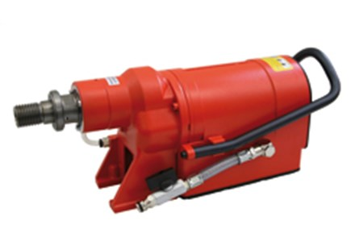

|  |  |
| --- | --- |
| Spanning (V) | 230 |
| Gewicht (Kg) | 14.7 |
| Toerental | 230/280/340/410/490/570 |
| Max. boordiameter (mm) | 370 |
| Vermogen (W) | 3700 |
| Opname | 1.25 |
| Lengte (mm) | 440 |
| Toepassing | Steen, Beton |