KSM
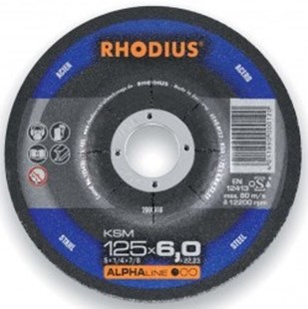
KSMRS A24Q-BF32
100 x 7,0 x 16,00 |  | 25 | 200008
115 x 7,0 x 22,23 |  | 25 | 200013
125 x 7,0 x 22,23 |  | 25 | 200018
180 x 7,0 x 22,23 |  | 10 | 200056
230 x 7,0 x 22,23 |  | 10 | 200090
Toepassing: staal

