RS28
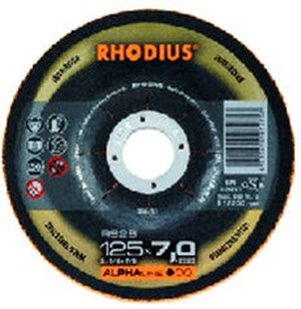
Ideaal voor machines met gering vermogen
RS28 30A24P9BF11718
115 x 7,0 x 22,23 |  | 25 | 208732
125 x 7,0 x 22,23 |  | 25 | 208733
180 x 7,0 x 22,23 |  | 10 | 208734
230 x 7,0 x 22,23 |  | 10 | 208735
Toepassing: RVS

