RS48
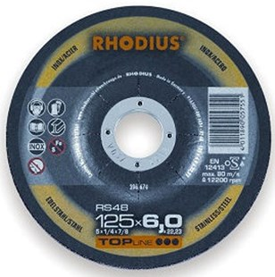
Speciaal geschikt voor randen
RS48 91A30U10BF1434
115 x 7,0 x 22,23 |  | 25 | 206672
125 x 7,0 x 22,23 |  | 25 | 206674
180 x 7,0 x 22,23 |  | 10 | 206677
230 x 7,0 x 22,23 |  | 10 | 206681
Toepassing: RVS

