XT10
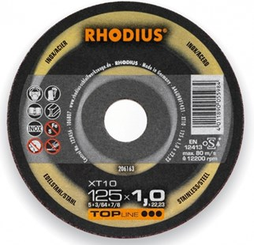
XT10 A46U9BF1432
50 x 1,0 x 6,00 | 50 | 206799
50 x 2,0 x 6,00 | 25 | 206800
65 x 1,0 x 6,00 | 50 | 206801
65 x 2,0 x 6,00 | 25 | 206802
75 x 1,0 x 6,00 | 50 | 209338
75 x 1,0 x 10,00 | 50 | 206803
75 x 2,0 x 6,00 | 25 | 209339
75 x 2,0 x 10,00 | 25 | 206804
100 x 1,0 x 15,00 | 25 | 208775
100 x 1,0 x 16,00 | 50 | 206285
115 x 1,0 x 22,23 | 50 | 206162
115 x 1,5 x 22,23 | 50 | 206164
125 x 1,0 x 22,23 | 50 | 206163
125 x 1,5 x 22,23 | 50 | 206165
150 x 1,5 x 22,23 | 25 | 206258
180 x 1,5 x 22,23 | 25 | 206259
230 x 1,9 x 22,23 | 25 | 206260

XTK10 A46U9BF1432
115 x 1,0 x 22,23 | 50 | 206166
115 x 1,5 x 22,23 | 50 | 206168
125 x 1,0 x 22,23 | 50 | 206167
125 x 1,5 x 22,23 | 50 | 206169
150 x 1,5 x 22,23 | 25 | 206261
180 x 1,5 x 22,23 | 25 | 206262
230 x 1,9 x 22,23 | 25 | 206263
Toepassing: RVS

