XT38
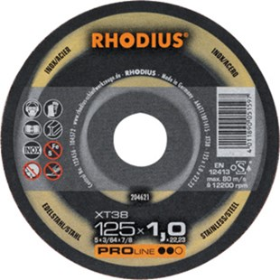
Ideaal voor machines met gering vermogen
XT38 A46T11BF1415
115 x 1,0 x 22,23 | 50 | 204619
115 x 1,5 x 22,23 | 50 | 203877
125 x 1,0 x 22,23 | 50 | 204621
125 x 1,5 x 22,23 | 50 | 203881
150 x 1,5 x 22,23 | 25 | 205700
180 x 1,5 x 22,23 | 25 | 205701
230 x 1,9 x 22,23 | 25 | 205702

XTK38 A46T11BF1423
115 x 1,0 x 22,23 | 50 | 205707
115 x 1,5 x 22,23 | 50 | 205706
125 x 1,0 x 22,23 | 50 | 205705
125 x 1,5 x 22,23 | 50 | 205704
150 x 1,0 x 22,23 | 25 | 209497
180 x 1,5 x 22,23 | 25 | 205721
230 x 1,9 x 22,23 | 25 | 205703
Toepassing: RVS

