XT67
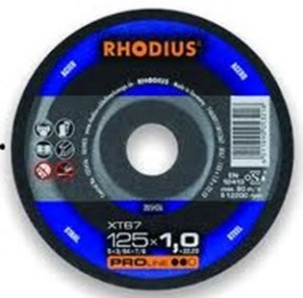
XT67 74A30T11BF1367
115 x 1,0 x 22.23 | 50 | 205425
115 x 1,5 x 22,23 | 50 | 202378
125 x 1,0 x 22,23 | 50 | 205426
125 x 1,5 x 22,23 | 50 | 202384
150 x 1,5 x 22,23 | 25 | 205709
180 x 1,5 x 22.23 | 25 | 205710
230 x 1,9 x 22,23 | 25 | 205711

XTK67 74A30T11BF1379
115 x 1,5 x 22.23 | 50 | 204791
125 x 1,5 x 22.23 | 50 | 204793
180 x 1,5 x 22,23 | 25 | 206034
230 x 1,9 x 22.23 | 25 | 206773
Toepassing: staal

