FT24
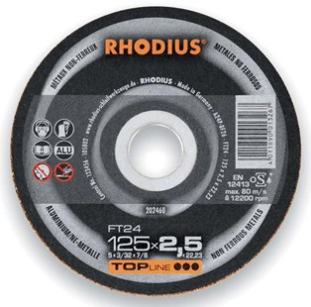
FT24 A24P-BF26
125 x 2,0 x 22,23 | 25 | 202460
180 x 2,5 x 22,23 | 25 | 201048
230 x 2,5 x 22,23 | 25 | 201055

FTK24 A24P-BF34
115 x 2,0 x 22,23 | 25 | 201064
125 x 2,0 x 22,23 | 25 | 201070
230 x 2,5 x 22,23 | 25 | 201079
Toepassing: NF-metalen

