FT33
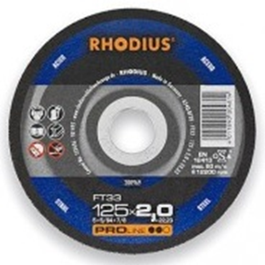
FT33 A24Q-BF20
100 x 2,0 x 16.00 | 25 | 200736
115 x 2,0 x 22.23 | 25 | 200961
115 x 3,0 x 22.23 | 25 | 200719
125 x 2,0 x 22.23 | 25 | 200969
125 x 3,0 x 22.23 | 25 | 200755
150 x 2,0 x 22.23 | 25 | 200782
150 x 3,0 x 22.23 | 25 | 200773
180 x 2,0 x 22.23 | 25 | 200975
180 x 3,0 x 22.23 | 25 | 200786
230 x 2,0 x 22.23 | 25 | 200979
230 x 3,0 x 22.23 | 25 | 200807

FTK33 A24Q-BF21
100 x 2,0 x 16.00 | 25 | 200840
100 x 3,0 x 16.00 | 25 | 200843
115 x 2,0 x 22.23 | 25 | 200983
115 x 3,0 x 22.23 | 25 | 200853
125 x 2,0 x 22.23 | 25 | 200988
125 x 3,0 x 22.23 | 25 | 200891
150 x 3,0 x 22.23 | 25 | 200922
180 x 2,0 x 22.23 | 25 | 200992
180 x 3,0 x 22.23 | 25 | 200928
230 x 2,0 x 22.23 | 25 | 200995
230 x 3,0 x 22.23 | 25 | 200943
Toepassing: staal

