Quattro-X Dust
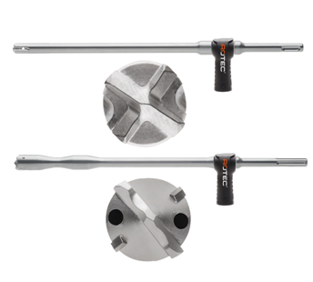
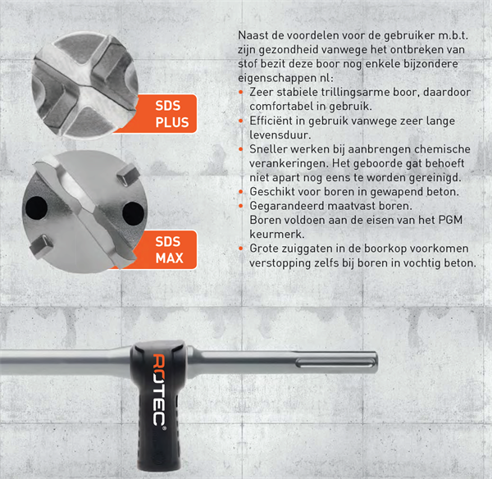
206.1121 | Rotec Quattro-X Dust SDS+ 12,0x325
206.1141 | Rotec Quattro-X Dust SDS+ 14,0x360
206.1161 | Rotec Quattro-X Dust SDS+ 16,0x360
206.1181 | Rotec Quattro-X Dust SDS+ 18,0x360
206.6161 | Rotec Quattro-X Dust SDS-MAX 16x600
206.6181 | Rotec Quattro-X Dust SDS-MAX 18x600
206.6201 | Rotec Quattro-X Dust SDS-MAX 20x600
206.6221 | Rotec Quattro-X Dust SDS-MAX 22x600
206.6241 | Rotec Quattro-X Dust SDS-MAX 24x600
206.6251 | Rotec Quattro-X Dust SDS-MAX 25x600
206.6281 | Rotec Quattro-X Dust SDS-MAX 28x600
206.6282 | Rotec Quattro-X Dust SDS-MAX 28x900
206.6301 | Rotec Quattro-X Dust SDS-MAX 30x600
206.6302 | Rotec Quattro-X Dust SDS-MAX 30x900
206.6321 | Rotec Quattro-X Dust SDS-MAX 32x600
206.6322 | Rotec Quattro-X Dust SDS-MAX 32x900
206.6351 | Rotec Quattro-X Dust SDS-MAX 35x600
206.6352 | Rotec Quattro-X Dust SDS-MAX 35x900
