

**Adapter rubber Ø 44 - Ø 52**

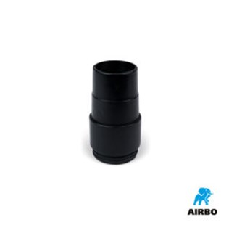

Adapter rubber ø44-ø52mm

– Bestelnummer: 500610