200-250-300 ECO
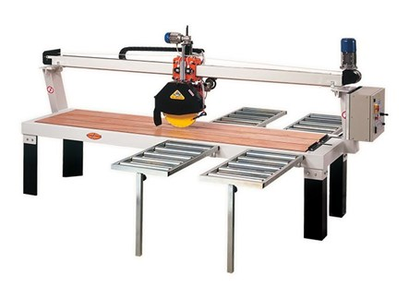
Verkrijgbaar in twee versies: handmatig en automatisch. Heavy-duty, goedkoop en gemakkelijk te gebruiken. Voorzien van een multiplexbank. Geschikt voor zowel kleine werkplaatsen als grote industrieën die steenachtige materialen verwerken. Snijdt van 90 tot 45°.

Technical Data
ITEM | MOD. | 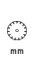 |  | 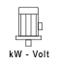 | 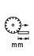 | 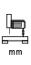 | 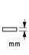 | 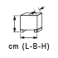 | 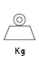
150552 | FRESA MANTA 200 ECO manuale | 450 - 30 | 2800 | 4 - 400* | 2000 | 250 | 150 | 290x91x121 | 340
150553 | FRESA MANTA 200 ECO manuale | 450 - 30 | 1400 | 4 - 400* | 2000 | 250 | 150 | 290x91x121 | 340
150550 | FRESA MANTA 200 ECO automatica | 450 - 30 | 2800 | 4 - 400* | 2000 | 250 | 150 | 314x91x121 | 360
150551 | FRESA MANTA 200 ECO automatica | 450 - 30 | 1400 | 4 - 400* | 2000 | 250 | 150 | 314x91x121 | 360
150602 | FRESA MANTA 250 ECO manuale | 450 - 30 | 2800 | 4 - 400* | 2500 | 250 | 150 | 340x91x121 | 395
150603 | FRESA MANTA 250 ECO manuale | 450 - 30 | 1400 | 4 - 400* | 2500 | 250 | 150 | 340x91x121 | 395
150601 | FRESA MANTA 250 ECO automatica | 450 - 30 | 2800 | 4 - 400* | 2500 | 250 | 150 | 364x91x121 | 410
150600 | FRESA MANTA 250 ECO automatica | 450 - 30 | 1400 | 4 - 400* | 2500 | 250 | 150 | 364x91x121 | 410
150652 | FRESA MANTA 300 ECO manuale | 450 - 30 | 2800 | 4 - 400* | 3000 | 250 | 150 | 390x91x121 | 450
150653 | FRESA MANTA 300 ECO manuale | 450 - 30 | 1400 | 4 - 400* | 3000 | 250 | 150 | 390x91x121 | 450
150651 | FRESA MANTA 300 ECO automatica | 450 - 30 | 2800 | 4 - 400* | 3000 | 250 | 150 | 414x91x121 | 470
150650 | FRESA MANTA 300 ECO automatica | 450 - 30 | 1400 | 4 - 400* | 3000 | 250 | 150 | 414x91x121 | 470
* Single phase also available - 2.2 kW - 2800/1400 RPM.

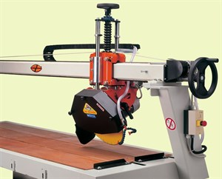 | 