Aanschuiftafel
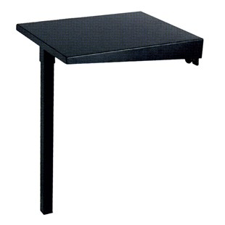

Technical Data
ITEM | AVAILABLE ON | Kg
17M001 | ALL MODELS* | 7
04NS000T00 | MINI MANTA | 4
04MS156T00 | ALL MODELS* | 6
* SIDE TABLE WITHOUT LEG

