Aluminium 150-200
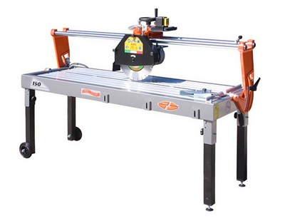

Technical Data
ITEM | MOD. |  |  | 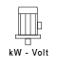 | 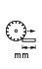 | 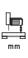 | 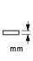 | 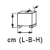 | 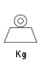
120350AL | MANTA 150 ALLUMINIUM | 350 | 2800 | 2,2-230* | 1500 | 150 | 110 | 197x66x77 | 89
120355AL | MANTA 150 ALLUMINIUM GRANIT | 350 | 1400 | 2,2-230* | 1500 | 150 | 110 | 197x66x77 | 89
120354AL | MANTA 200 ALLUMINIUM | 350 | 2800 | 2,2-230 | 2000 | 150 | 110 | 250x88x77 | 106
120359AL | MANTA 200 ALLUMINIUM GRANIT | 350 | 1400 | 2,2-230 | 2000 | 150 | 110 | 250x88x77 | 106
120266AL | MANTA 200 ALLUMINIUM LX GRANIT | 450 - 40 | 4 - 400 | 1400 | 2000 | 150 | 150 | 275x88x81 | 136
* Triphase version in also available
