Aluminium 65-85-100-120
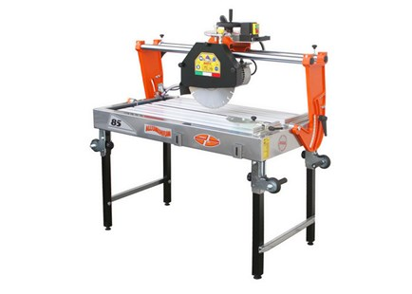

Technical Data
ITEM | MOD. | 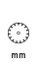 |  | 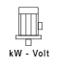 | 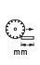 | 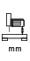 | 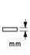 | 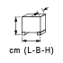 | 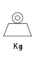
120150AL | MANTA 65 Alluminium | 350 | 2800 | 2,2 - 230* | 650 | 150 | 110 | 107x66x77 | 61
120200AL | MANTA 85 ALLUMINUM | 350 | 2800 | 2,2 - 230* | 850 | 150 | 110 | 127x66x77 | 66
120202AL | MANTA 85-550 ALLUMINIUM | 550 | 1400 | 2,2 - 230* | 695 | 210 | 200 | 127x66x85 | 75
120204AL | MANTA 85-550 ALLUMIN. TRIF. | 550 | 1400 | 3,6-400 | 695 | 210 | 200 | 127x66x85 | 76
120250AL | MANTA 100 ALLUMINUM | 350 | 2800 | 2,2 - 230* | 1000 | 150 | 110 | 155x66x77 | 72
120300AL | MANTA 120 ALLUMINIUM | 350 | 2800 | 2,2 - 230* | 1200 | 150 | 110 | 171x66x77 | 79
* 3 kW - triphase version is also available
