Diagonal square
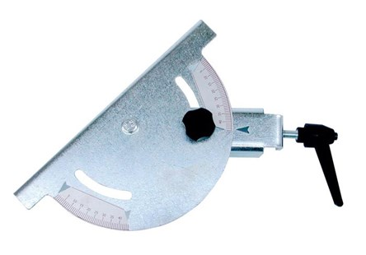

Technical Data
ITEM | AVAILABLE ON
17M005 | All models

